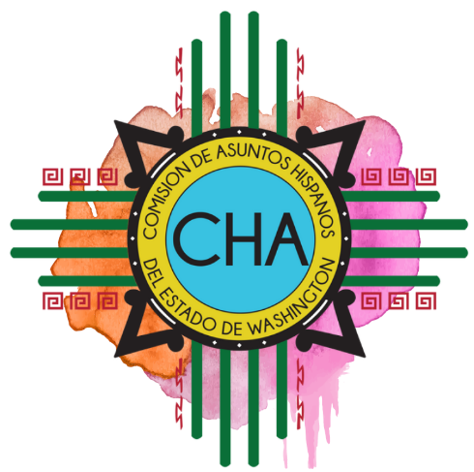
Commission on Hispanic Affairs
1st Quarter Commission Meeting
Patricia Wade Temple Conference Room
3240 Fort Rd Toppenish, WA 98948

Saturday, March 7th

8:30-9:00 a.m. Coffee and Mingling

9:00-9:15 a.m. Call to Order
Dr. Andrew Sund, President of Heritage University
Approve Agenda
Welcome, Introductions

9:15-9:45 a.m. Teambuilding

9:45-10:00 a.m. Business
- Approve minutes:
  - December 2019 in person,
  - January 2020 call, and
  - February 2020 call.

10:00-10:15 a.m. Break

10:15-11:15 a.m. Committee Breakout Sessions

11:15-11:30 a.m. Real ID Proposal

11:30-11:45 a.m. Legislative and Decision Package Request Timelines and Process

11:45 a.m.-12:30 p.m. LUNCH

12:30 p.m. Open House

1:00 p.m. Census – Luis Gomez & Nancy Rocha Aguilar

2:00 p.m. Community Forum

3:00 p.m. Adjourn

