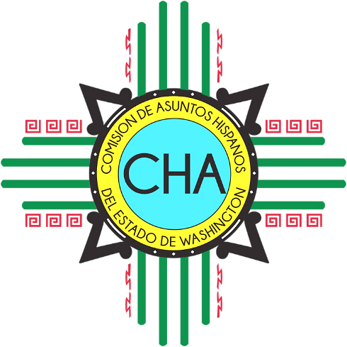
CHA Meeting
City of Seattle; City Hall
Berth Knight Landes Room
600 4th Ave
Seattle, WA 98104

Saturday, March 2nd

8:30 a.m. Coffee and Mingling

9:00 a.m. Welcome and Introductions
Ice-Breaker

9:30 a.m. Points of Collaboration

10:45 a.m. Break

11:00 a.m. Business: Approval of Minutes
- 2017 Minutes (all)
- December 2018 in-person
- January Conference Call
- February Conference Call

11:30 a.m. Lunch
(On your own)

1:00 p.m. Community Partner Engagement Session

3:00 p.m. Adjourn

