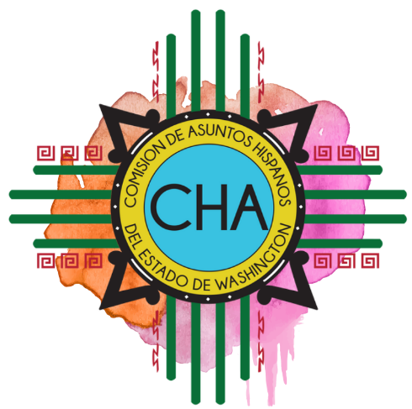
Commission on Hispanic Affairs
4th Quarter Commission Meeting
Legislative Building – Columbia Room
416 Sid Snyder Ave SW, Olympia WA 98504

Saturday, December 7th

8:30-9:00 a.m. Coffee and Mingling

9:00-9:30 a.m. Call to Order
Approve Agenda
Welcome and Introductions

9:30-10:30 a.m. Teambuilding

10:30-10:45 a.m. Break

10:45-11:00 a.m. Business
- September, October, November Minutes
- Commission Meeting 2020 Schedule
- Per Diem Policy Change

11:00-11:45 a.m. Legislative Priorities and Restructure Proposal

11:45 a.m.-12:30 p.m. LUNCH

12:30 p.m. Open House

1:00 p.m. DOL: REAL ID

1:30 p.m. OWMBE: Disparity Study Update

2:00 p.m. DOT: Outreach

2:30 p.m. Community Forum

3:00 p.m. Adjourn

