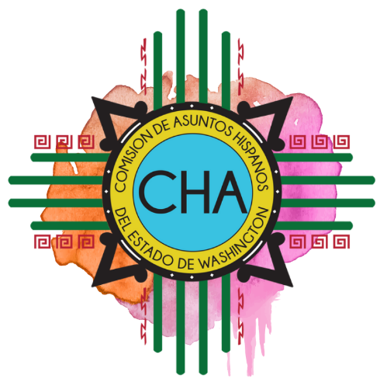
CHA Monthly Conference Call
Skype: Join Skype Meeting
(360) 407-3854; Code: 4290239

Friday, April 10, 2020
10:00 AM- 11:00 AM

- Roll Call

- Overview of Agenda

- EC Updates

- COVID-19 Roundtable

- Adjourn

