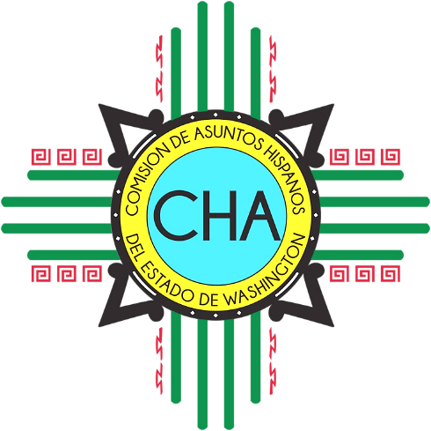
CHA Monthly Conference Call
Skype: Join Skype Meeting
(360) 407-3854; Code: 4290239

Friday, July 12th, 2019
10:00 AM- 11:00 AM

- Roll Call

- Overview of Agenda

- Chair and Vice-Chair Updates
  - Chair
  - Vice-Chair

- Commissioner Updates

- Executive Director Updates

- Communications and External Relations Manager Updates

- Adjourn

