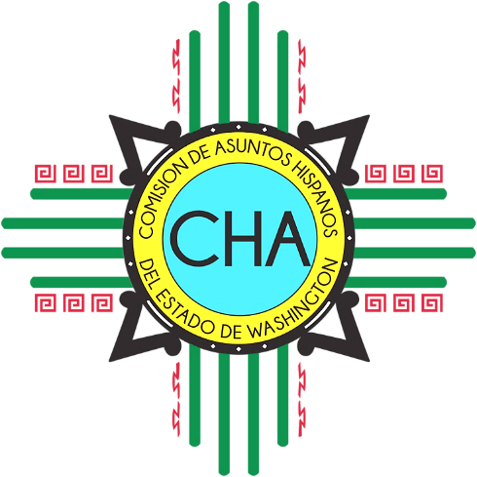
CHA Monthly Conference Call
Skype: Join Skype Meeting
(360) 407-3854; Code: 4290239

Friday, June 14th, 2019
10:00 AM- 11:00 AM

- Roll Call

- Overview of Agenda

- Chair and Vice-Chair Updates
  - Chair
    - Influence Model
    - Tier Structure
    - Three Year Plan

- Commissioner Updates

- Executive Director Updates
  - Call for Board Development Committee members
  - Designation Map
  - Status: New FTE
  - Status: Fiscal Year End

- Special Projects and Ops Manager Updates
  - Operations
  - Magazine
  - Census 2020

- Adjourn

