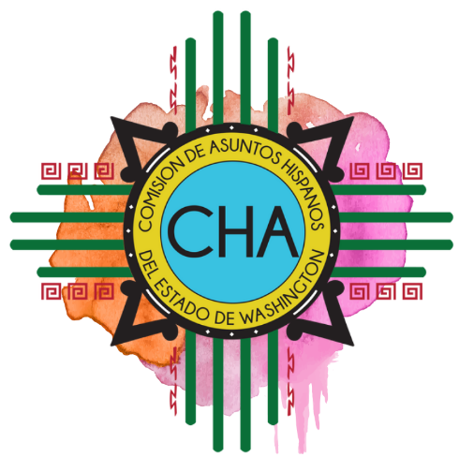
CHA Monthly Conference Call
Skype: Join Skype Meeting
(360) 407-3854; Code: 4290239

Friday, October 11, 2019
10:00 AM- 11:00 AM

- Roll Call

- Overview of Agenda

- Updates
  - Chair

  - Commissioners

  - Development Committee

  - Operations and Special Projects

  - Communications and External Relations

  - Executive Director

- Adjourn

